**Name: Bao Chau**

**Mav ID: 1001668479**

# PHONEBOOK API INSTRUCTION

* **Description of project:** 
  + This is a Python code for a RESTful API built with FastAPI that interacts with a SQLite database. The API allows users to add and retrieve and delete phonebook entries, which consist of a person's full name and phone number.
  + It uses regular expression (re) for data validation and SQLAlchemy as the ORM.
  + The application uses FastAPI, a Python web framework, for creating the REST API.
  + The SQLite database is used for storing the phone book data.
* **Stack Used:** 
  + Python: Multipurpose programming language with rich library collection
  + fastapi: FastAPI is a modern, fast (high-performance) web framework for building APIs with Python 3.7+ based on standard Python type hints.
  + uvicorn: Uvicorn is a lightning-fast ASGI server implementation, using uvloop and httptools.
  + sqlalchemy: SQLAlchemy is a popular SQL toolkit and ORM for Python. It provides a set of high-level API to work with relational databases.
  + pydantic: Pydantic is a data validation and settings management library, which uses Python type annotations to validate and parse data.
  + Postman: It is a collaboration platform for API development that allows users to design, test, and document APIs.

* **Instructions for building and running software and unit tests:** 
  + **Running the code:**
* Open Visual Studio.
* Click on "File" in the top left corner and select "Open Folder".
* Navigate to the folder where your Python code is located and select it.
* If your code requires any dependencies, make sure they are installed in your Python environment.
* Open the "Terminal" tab in Visual Studio by clicking on "View" and then "Terminal".
* Install libraries by using command in terminal: **pip install -r requirements.txt** ▪ In the terminal, navigate to the folder containing your Python code.
* In our case keep the app.py tab open.
  + - To run the app, type the command in terminal: **uvicorn app:app –reload**
    - Following is output when you run code successfully.

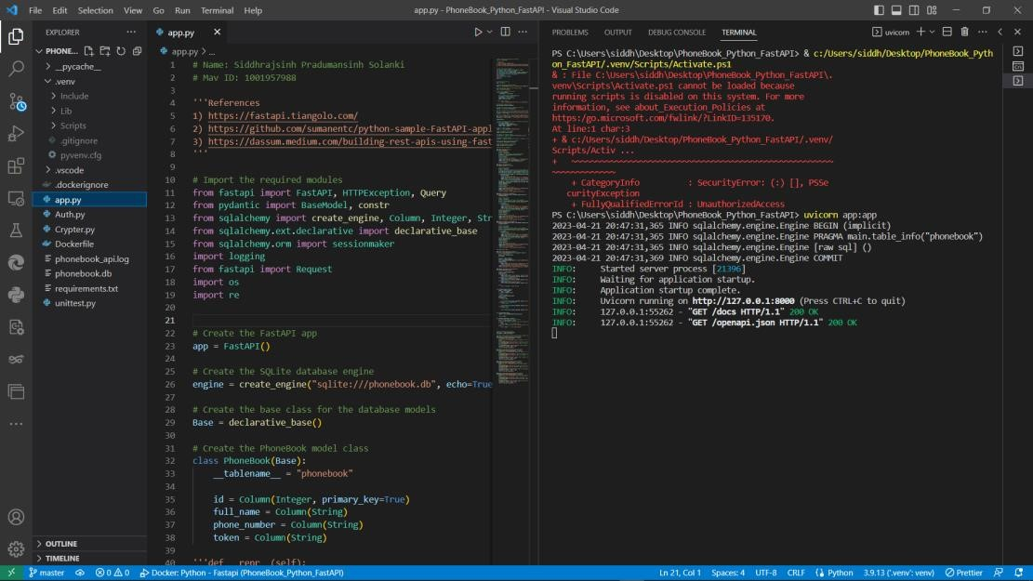

* + **Creating Docker image:** 
    - Docker files are created and setup.
    - Build it using command: docker build -t phonebook . ▪ Run image: docker run -p 8000:8000 phonebook ▪ Once build and run finishes, open browser window.
    - Navigate to: http://127.0.0.1:8000/docs